**CHOUCAS BLANC \*\*\*\*\***

Chalet Choucas Blanc is an exclusive property with an official 5 star rating, in a luxury residence, ideally situated right in the centre of Val D'Isere. The chalet sleeps 6 adults and up to 2 children

On the first floor, this luxury chalet provides accommodation that is spacious, soothing and intimate. At more than 160m2 plus 2 generous balconies, the chalet is generously sized and the abundance of large windows lets light flood in throughout the day. The décor and furnishing is designed and completed to the highest standard by a highly regarded London based interior designer

Guests of the Choucas Blanc will delight in full breakfasts, afternoon tea and cakes and 3 course evening meals plus a cheeseboard together with wine, beer and soft drinks

Located on the Avenue Olympique, Val D'Isere's main high street and a 4 minute walk from the slopes, you really couldn't pick a better spot!

The chalets prime location gives easy access to the many facilities the resort has to offer. The chalet is a 250 metres walk to the Solaise nursery slopes, the closest free bus stop which accesses all major resort lifts is 50 metres from the front of the Choucas building

**The Chalet**

Chalet Choucas Blanc is an exclusive property in a luxury residence, ideally situated right in the heart of Val D'Isere between the resort’s 2 central roundabouts. The village facilities, a fantastic choice of restaurants, bars and shops are immediately outside the Choucas building. From the balconies at the front (south facing) and back (north facing) you will also enjoy breath-taking views of both the famous Val d′Isere mountains and the resort itself.

On the first floor, this luxury chalet provides accommodation that is spacious, soothing and intimate. The décor and furnishing is designed and completed to the highest standard by a highly regarded London based interior designer

The entrance hall includes cupboards with individual baskets for your helmets, gloves socks, snoods, woolly hats….

From the entrance hall you come straight into the grand open plan lounge, dining, kitchen area. At almost 100m2, this is undoubtedly one of the biggest living spaces in Val D’Isere complete with a generous dining table to seat 8 people and a sumptuous lounge area with a wide choice of comfy seating

The lounge includes a roaring log fire which our chalet hosts will be delighted to set up for you (to comply with building regulations). From the balcony you can directly access the front balcony to soak up the sunshine and see skiers and snowboarders on the famous Face de Bellevarde Olympic downhill or watch life passing on the village street below

The 85” Smart TV allows access to most UK channels and the major streaming services. The chalet is fitted with WiFi and boosters to ensure a strong signal throughout

The fully equipped kitchen where out hosts will prepare all meals includes a huge breakfast bar with 4 high stools. The corridor contains ample storage space

Heading down the corridor to the bedrooms, there is a spare shower / toilet room which also serves as the laundry and there is sleeping space for 6 adults and up to 2 children. All bedrooms have en suite facilities (2 with baths and 1 with a shower). The bedrooms also share a generous balcony which looks to the mountains to the opposite side to the ski area

To complete your stay, the ground floor of the Choucas residence includes a ski locker with shoe warmers (please note all skis, snowboards, boots must be kept in the ski lockers) for up to 8 people and the basement has a garage with space for your vehicle

**Sleeping arrangements**

The bedrooms are on the back of the chalet so you wont be disturbed

1 x Master bedroom with double (180cms bed) and en-suite bathroom with hairdryer and toiletries

1 x Second bedroom with double (180cms bed) or twin beds and en-suite shower room with hairdryer and toiletries

The second bedroom has an adjoining kids bedroom with bunk beds (suitable for children aged 12 and under)

1 x Double bedroom with (180cms bed) and en-suite bathroom with hairdryer and toiletries

**Inclusive Board Basis**

7 nights accommodation in our beautiful chalet

All catering provided by our dedicated English speaking chalet team, in the chalet

Full daily continental breakfast service for 7 days of the holiday plus hot food cooked to order - eggs, omelette, smoothies on 6 of the days

Afternoon tea / coffee and freshly baked cake / muffins / cookies

3 course dinner and a cheeseboard togerther with French / Savoyard wines on 6 of the nights (Wednesday off). Our staff prepare a well balanced menu but will agree the specific menu for your week with you prior to your arrival - sample menu

Fresh and fully stocked fruit bowl

Daily cleaning and making beds

French lagers are provided free of charge

Towels (with midweek change), dressing gowns and bed linen

Roaring log fire – please ask our chalet hosts to set this up for you (according to local regulations)

Our staff know the chalet and have been to Val D'Isere countless times so are well placed to provide advice on the ski area, the restaurants and the resort in general

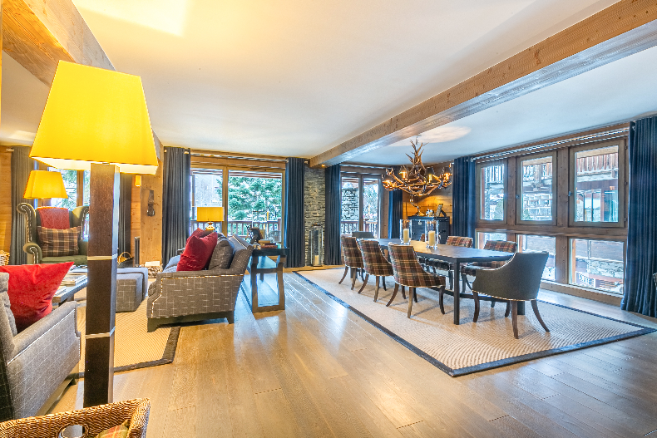

Dining Room

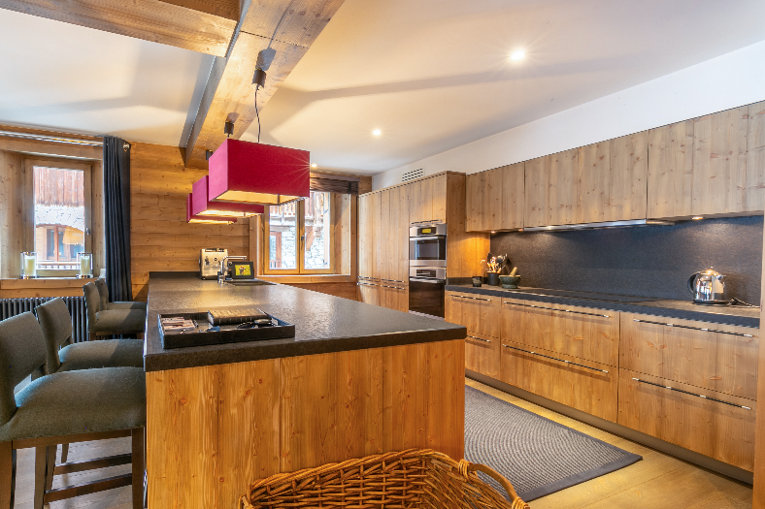

Kitchen



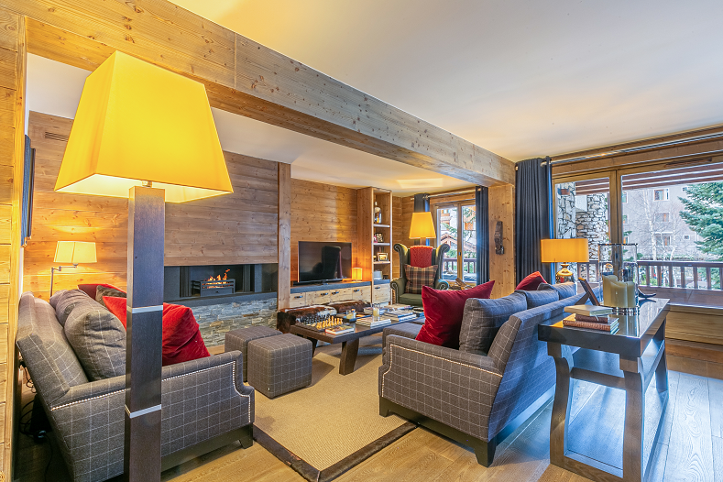

Lounge

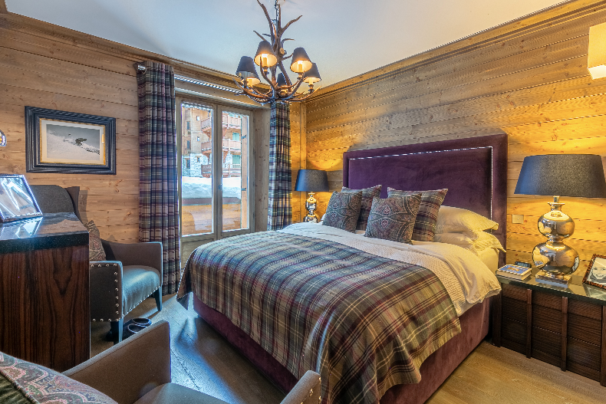

Master Bed

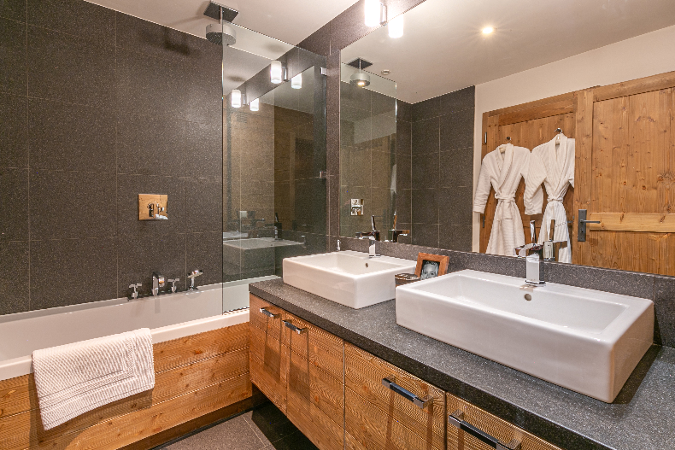

Master Bath

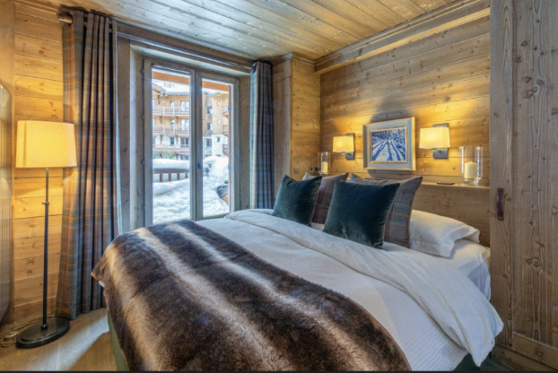

Bedroom 2

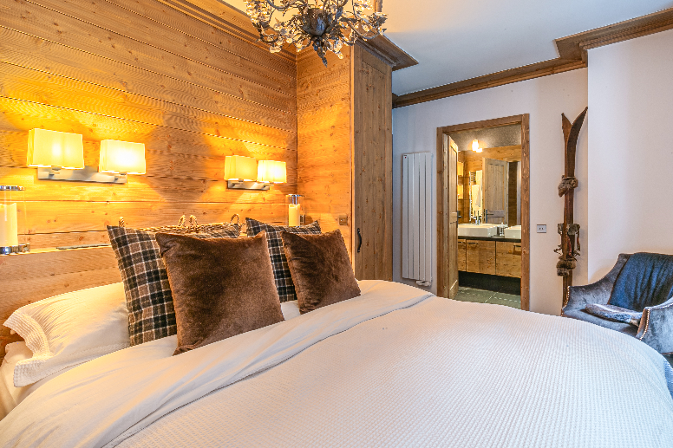

Bedroom 3

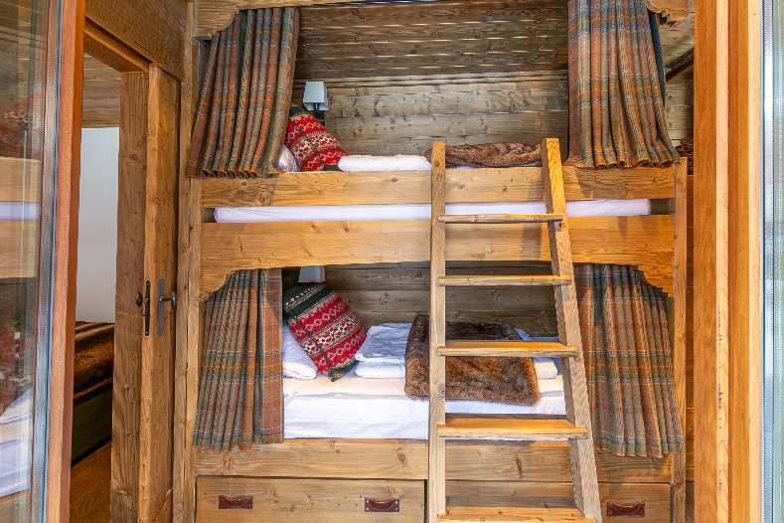

Bunk room

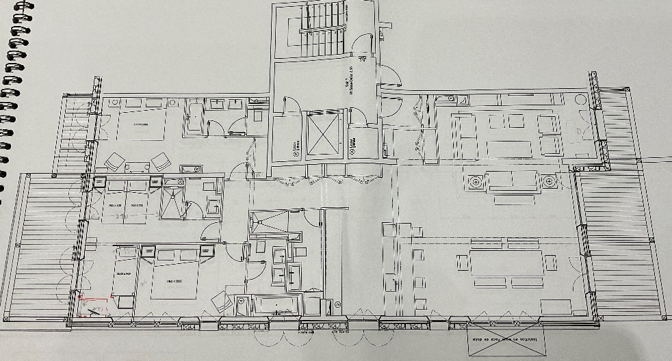

Floor Plan

**Total price (catered chalet board)**  
Up to 6 adults & 2 children

**Nov 30th    £7708      SOLD OUT**

**Dec 7th       £7708      SOLD OUT**

**Dec 14th    £9300       AVAILABLE**

**Dec 21st     £15798    AVAILABLE**

**Dec 28th    £19782    AVAILABLE**

**Jan 4th      £10368     AVAILABLE**

**Jan 11th    £9583       AVAILABLE**

**Jan 18th    £9583       AVAILABLE**

**Jan 25th    £11382    AVAILABLE**

**Feb 1st       £12744     AVAILABLE**

**Feb 8th      £13752      AVAILABLE**

**Feb 15th   £20502      SOLD OUT**

**Feb 22nd  £12582      AVAILABLE**

**Mar 1st      £11250      AVAILABLE**

**Mar 8th     £10674      AVAILABLE**

**Mar 15th   £10574     AVAILABLE**

**Mar 22nd  £11679      AVAILABLE**

**Mar 29th   £15000      SOLD OUT**

**Apr 5th      £14850      AVAILABLE**

**Apr 12th    £10470      AVAILABLE**

**Apr 19th    £8934        SOLD OUT**

**Apr 26th     £7708       SOLD OUT**

All prices are in GBP for 7 nights catered chalet board and are for sole occupancy of the chalet for up to 6 adults and 2 children (under 12 years) sharing

Click here to see inclusions in [catered chalet board](internal://96344981-fde5-4bc3-911d-3ab009ee50e3)

A deposit of 25% is payable to reserve your stay, final balances are due 8 weeks prior to travel. A security deposit of £1000 per booking is also payable with the final balance - this will be repaid to you within 7 days of your departure from resort

Should you wish to book flights, private transfers, ski passes, ski hire, ski school, insurance etc please contact us as our sister company can organise this for you, please ask us

**Contact us**

Telephone: +44 7767 366520

E-mail: [choucasblanc@hotmail.com](mailto:email@example.com)

[www.choucasblanc.com/booking-request](http://www.choucasblanc.com/booking-request)

Address: Chalet Choucas Blanc, A102 Choucas Building, 881 Avenue d'Olympique, Val D'Isere, 73150, Savoie, France