CHOUCAS BLANC *****
Chalet Choucas Blanc is an exclusive property with an official 5 star rating, in a luxury residence, ideally situated right in the centre of Val D'Isere. The chalet sleeps 6 adults and up to 2 children
On the first floor, this luxury chalet provides accommodation that is spacious, soothing and intimate. At more than 160m2 plus 2 generous balconies, the chalet is generously sized and the abundance of large windows lets light flood in throughout the day. The décor and furnishing is designed and completed to the highest standard by a highly regarded London based interior designer
Guests of the Choucas Blanc will delight in full breakfasts, afternoon tea and cakes and 3 course evening meals plus a cheeseboard together with wine, beer and soft drinks
Located on the Avenue Olympique, Val D'Isere's main high street and a 4 minute walk from the slopes, you really couldn't pick a better spot!
The chalets prime location gives easy access to the many facilities the resort has to offer. The chalet is a 250 metres walk to the Solaise nursery slopes, the closest free bus stop which accesses all major resort lifts is 50 metres from the front of the Choucas building
The Chalet
Chalet Choucas Blanc is an exclusive property in a luxury residence, ideally situated right in the heart of Val D'Isere between the resort’s 2 central roundabouts. The village facilities, a fantastic choice of restaurants, bars and shops are immediately outside the Choucas building. From the balconies at the front (south facing) and back (north facing) you will also enjoy breath-taking views of both the famous Val d′Isere mountains and the resort itself.
On the first floor, this luxury chalet provides accommodation that is spacious, soothing and intimate. The décor and furnishing is designed and completed to the highest standard by a highly regarded London based interior designer
The entrance hall includes cupboards with individual baskets for your helmets, gloves socks, snoods, woolly hats….
From the entrance hall you come straight into the grand open plan lounge, dining, kitchen area. At almost 100m2, this is undoubtedly one of the biggest living spaces in Val D’Isere complete with a generous dining table to seat 8 people and a sumptuous lounge area with a wide choice of comfy seating
The lounge includes a roaring log fire which our chalet hosts will be delighted to set up for you (to comply with building regulations). From the balcony you can directly access the front balcony to soak up the sunshine and see skiers and snowboarders on the famous Face de Bellevarde Olympic downhill or watch life passing on the village street below
The 85” Smart TV allows access to most UK channels and the major streaming services. The chalet is fitted with WiFi and boosters to ensure a strong signal throughout
The fully equipped kitchen where out hosts will prepare all meals includes a huge breakfast bar with 4 high stools. The corridor contains ample storage space
Heading down the corridor to the bedrooms, there is a spare shower / toilet room which also serves as the laundry and there is sleeping space for 6 adults and up to 2 children. All bedrooms have en suite facilities (2 with baths and 1 with a shower). The bedrooms also share a generous balcony which looks to the mountains to the opposite side to the ski area
To complete your stay, the ground floor of the Choucas residence includes a ski locker with shoe warmers (please note all skis, snowboards, boots must be kept in the ski lockers) for up to 8 people and the basement has a garage with space for your vehicle
Sleeping arrangements
The bedrooms are on the back of the chalet so you wont be disturbed
1 x Master bedroom with double (180cms bed) and en-suite bathroom with hairdryer and toiletries
1 x Second bedroom with double (180cms bed) or twin beds and en-suite shower room with hairdryer and toiletries
The second bedroom has an adjoining kids bedroom with bunk beds (suitable for children aged 12 and under)
1 x Double bedroom with (180cms bed) and en-suite bathroom with hairdryer and toiletries

Inclusive Board Basis
7 nights accommodation in our beautiful chalet
All catering provided by our dedicated English speaking chalet team, in the chalet
Welcome champagne served on arrival
Full daily continental breakfast service for 7 days of the holiday plus hot food cooked to order - eggs, smoothies on 6 of the days
Afternoon tea / coffee and freshly baked cake / muffins / cookies on 6 of the days
3 course dinner plus cheeseboard with French / Savoyard wines on 6 of the nights (Wednesday off). Our staff prepare a well balanced menu but will agree the specific menu for your week with you prior to your arrival - sample menu
Fresh and fully stocked fruit bowl
Daily cleaning and making beds
French lagers are provided free of charge
The chalet has a fully stocked bar and our staff will serve guests their favourite spirits and mixers (10€ for a double measure)
Towels (with midweek change), dressing gowns and bed linen
Toiletries - shampoo, conditioner and shower gel in each of the bathrooms
Roaring log fire – please ask our chalet hosts to set this up for you (according to local regulations)
Our staff know the chalet and have been to Val D'Isere countless times so are well placed to provide advice on the ski area, the restaurants and the resort in general
Luxury Spa
The Choucas Blanc has everything to make our guests stay perfect with the exception of a spa and pool!
So, new for 2026, we have agreed a partnership with the Pure Spa at the 4 star Tsantelina hotel which is a short walk from the Choucas Blanc (cross the main road, turn left and walk approximately 150m)
The two storey Pure Spa has a gym with Technogym machines, kinesis strength training, swimming pool, jacuzzi, steam and sauna. All guests have access to lockers and changing rooms, dressing gowns and towels.
The Pure Spa also offers a wide range of massage treatments with professional therapists see spa menu
Guests of the Choucas Blanc pay a reduced rate of 30€ per adult for single entry to the Spa including unlimited access to the gym, pool jacuzzi, steam and sauna
For massage bookings please call at least 24 hours in advance. If you wish to use the pool and gym you should also call ahead of visiting on +33 4 79 06 23 56

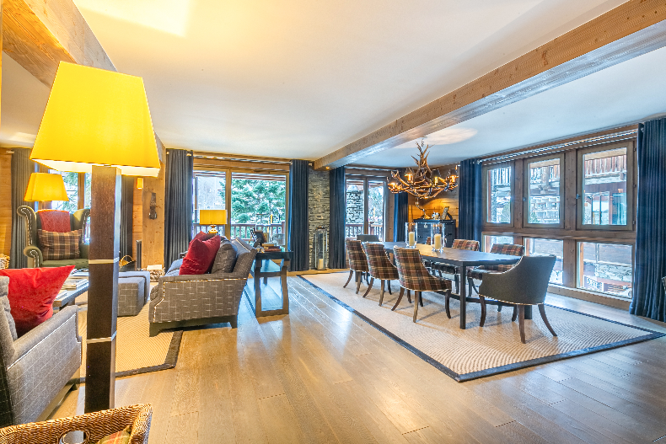
Dining Room

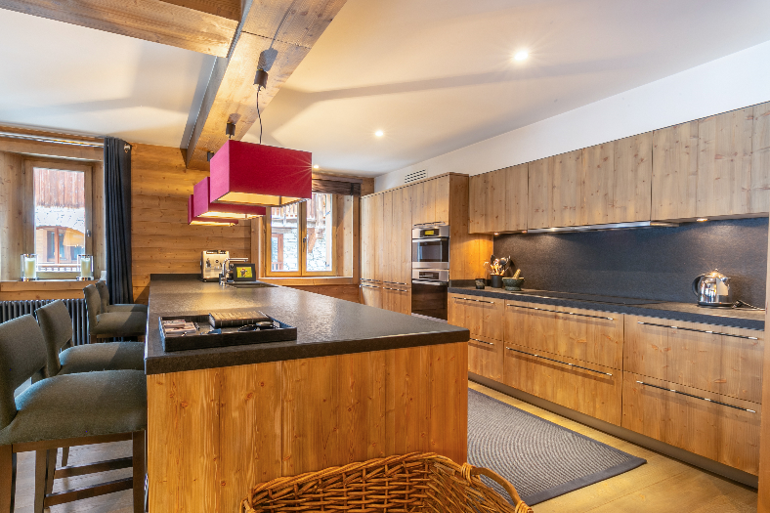
Kitchen

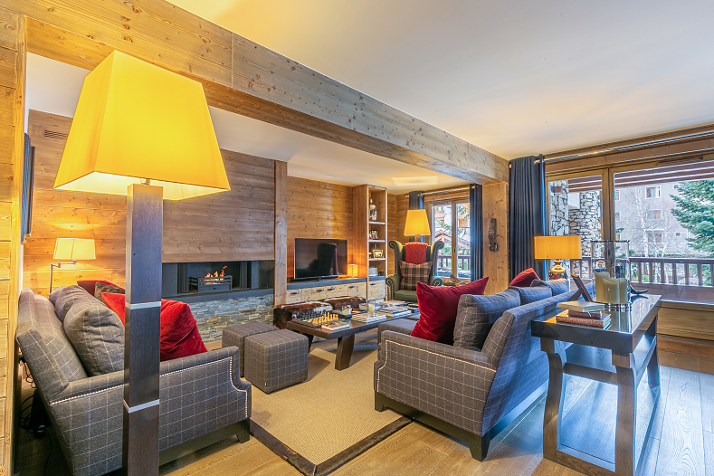
Lounge

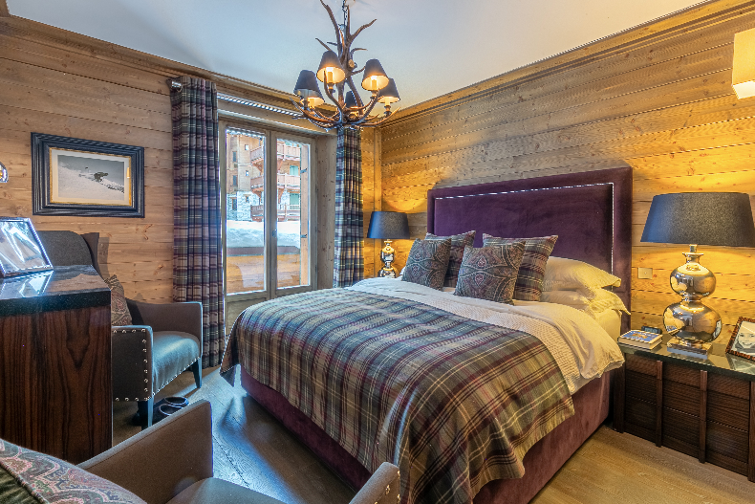
Master Bed
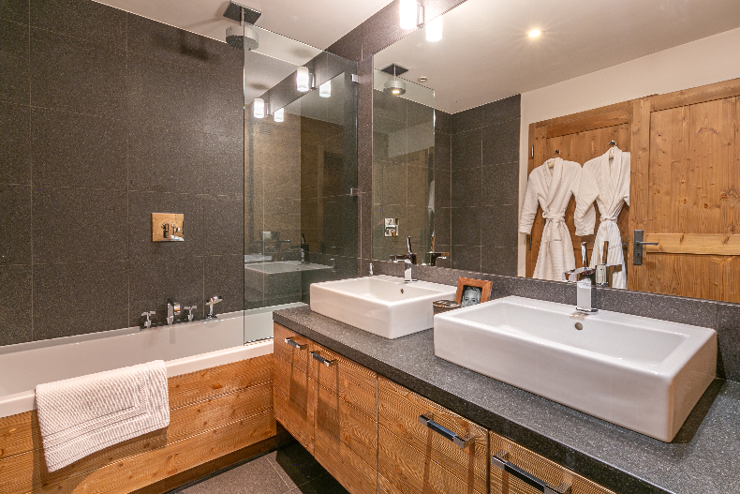
Master Bath

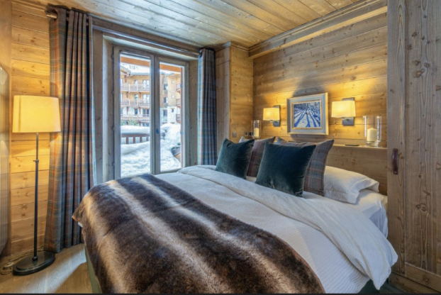
Bedroom 2
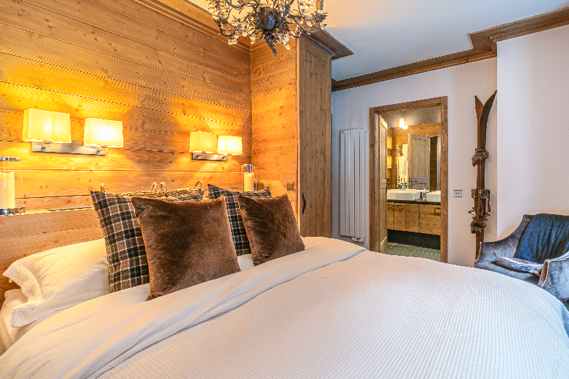
Bedroom 3

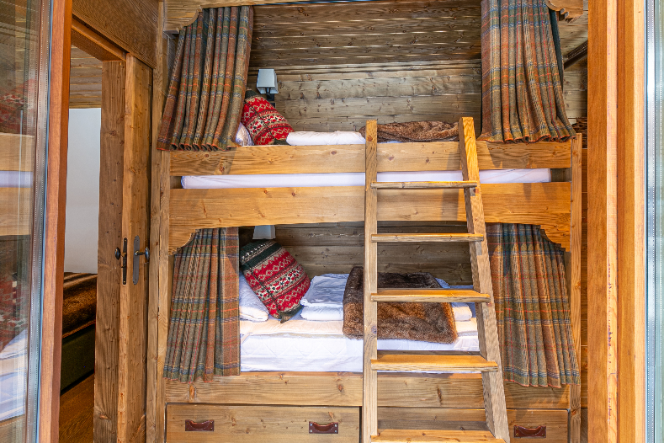
Bunk room
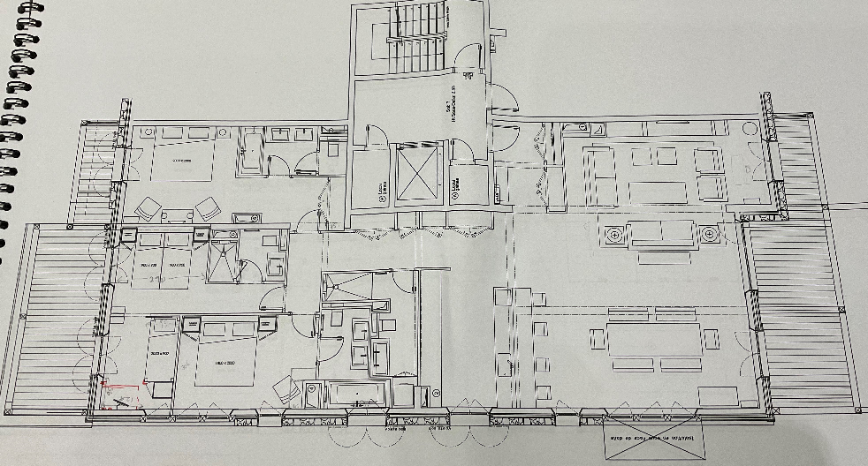
Floor Plan

Total price ( 5 star catered chalet board)
Up to 6 adults & 2 children
Preview prices for 2026/27 season – for latest availability please visit the website
Nov 29th £7800
Dec 6th £9250
Dec 13th £11160
Dec 20th £21958
Dec 27th £25717
Jan 3rd £12442
Jan 10th £10542
Jan 17th £10542
Jan 24th £12520
Jan 31st £14018
Feb 7th £15127
Feb 14th £24602
Feb 21st £13840
Feb 28th £12375
Mar 7th £11741
Mar 14th £11741
Mar 21st £14004
Mar 28th £18000
Apr 4th £17820
Apr 11th £12564
Apr 18th £12564
Apr 25th £10721

All prices are in GBP for 7 nights catered chalet board and are for sole occupancy of the chalet for up to 6 adults and 2 children (under 12 years) sharing
A deposit of 25% is payable to reserve your stay, final balances are due 8 weeks prior to travel. A security deposit of £1000 per booking is also payable with the final balance - this will be repaid to you within 7 days of your departure from resort
Should you wish to book flights, private transfers, ski passes, ski hire, ski school, insurance etc please contact us as our sister company can organise this for you, please ask us
Please note the tourist tax (taxe de sejour) is payable locally during your stay. This is approximately 4€ per adult and per night
Contact us
Telephone: +44 7767 366520
E-mail: choucasblanc@hotmail.com
www.choucasblanc.com/booking-request
Address: Chalet Choucas Blanc, A102 Choucas Building, 881 Avenue d'Olympique, Val D'Isere, 73150, Savoie, France

